Answer 8
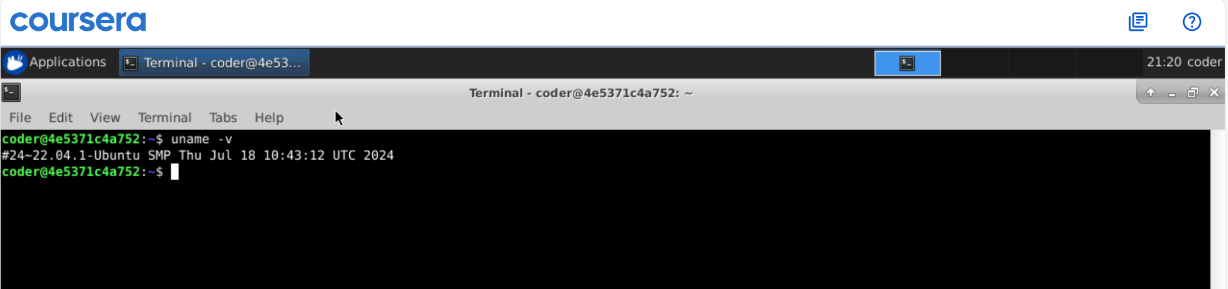
Explanation: So uname with -v option gives us the current version of the kernal and if we want all the info about the kernal we can use -a option. We can also use -r option to get Kernal release version.

